Project Team Charter
ME476C: Capstone I
Signature Cover Page
Each team member will copy the following statement in their own handwriting (LEGIBLY) in one of the designated areas below:
I agree to do an equal amount of work in the team. I understand that my grade will reflect my effort in the team.
Print Name: Sam Mangialardi
Signature:
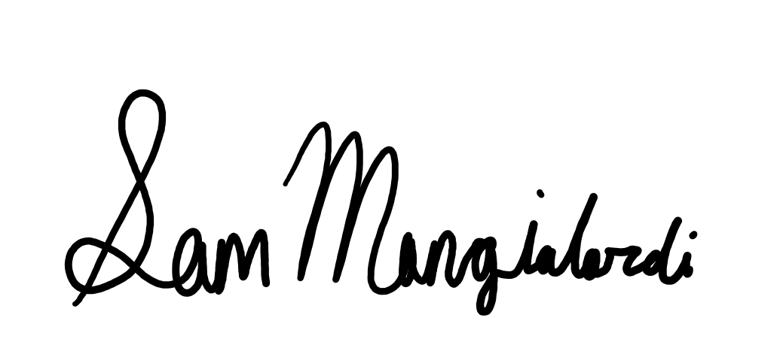
Print Name: Jake West
Signature:
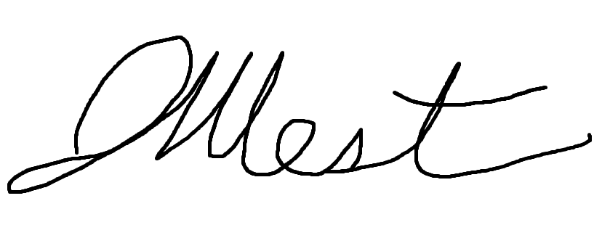
Print Name: Timothy Anderson
Signature:
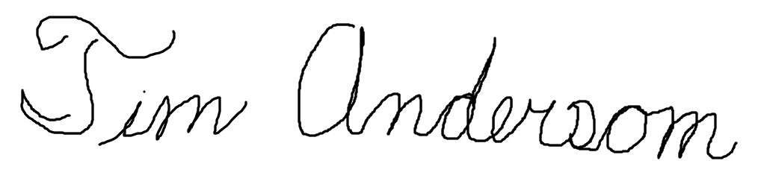
Print Name: Alex Soto
Signature:
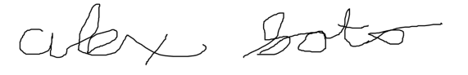
Print Name: Michael Wilson
Signature:
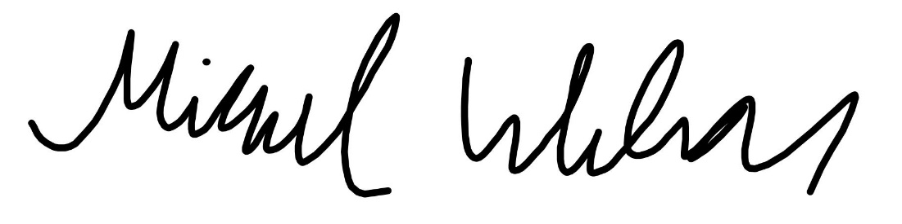
Print Name: Andrea Hernandez Limon
Signature:
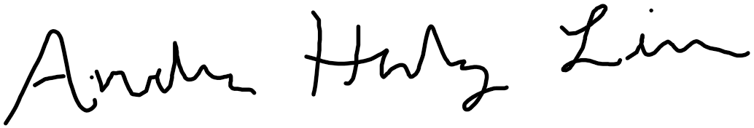

Team Charter for Senior Capstone Design Project
1. Team Purpose:
The purpose of this team is to complete a Capstone project that is sponsored by Northrop Grumman. The main goal of this project is to design, analyze, and build a functional prototype door system that will stay closed when subjected to potential pressure differences during flight. The main stakeholders of this project are Northrop Grumman, Daniel Johnson (Northrop Grumman’s contact), and NAU.
Expectations of the team are to have a functional prototype with the supplemental documentation of the entire design process. It is expected that the design will meet all of Northrop Grumman’s design requirements listed in the project proposal. In addition, it is expected that team will participate in regular mentor meetings, a system requirements review, a preliminary design review, a critical design review, and finally attend Northrop Grumman’s University Day in which the team will have a final presentation for Northrop Grumman employees. Lastly, the team must complete all NAU deliverables/requirements for Capstone classes.
The main expectation from the team is an opportunity to apply what we have learned in class to a real-world engineering problem while being able to work with one of the biggest companies in the aerospace/defense industry. The team is eager to gain hands-on experience and learn from professionals in the field. Regarding project deliverables, the team hopes to meet all the design requirements and provide a high-quality functional prototype that will meet Northrop Grumman’s standards of quality. We hope to maintain a positive representation of the team and NAU as we pursue this opportunity of professional networking, insightful experience, and quality education.
2. Team Goals:
Our team is tasked to create a design and basic prototype that is approved by the managers at Northrop Grumman. Since our team is sponsored to do a project for the company, the team plans to fulfill the requests and client objectives for our project. The door design will be functional and improve on their current system implemented in their aircraft. The team members are willing to commit a level of performance that will fulfil the goals set out by the team and Northrop Grumman, after they meet and finish briefing on the design needs. The team goal for this course is the provide a project that earns the team an A. The team also aims to create a project that is well accepted by Northrop Grumman, as they are the sponsors and client of our work. The goal is to have weekly meeting with Dr. Trevas, and a weekly or biweekly meeting with our client, Daniel Johnson. In addition, the team will have individual meetings over Teams or in person to keep active communication and ensure deliverables are finished on time.
The team plans to have a full CAD Model of the design, a functional prototype, an assembly/use demonstration, progress reports to Northrop Grumman, and a final presentation. The design needs to able to be scaled to fit various aircrafts, be safe of electrostatic charges and harmful contaminates, and withstand the pressure standards and safety factors. The team will be prepared to make several presentations to the staff at Northrop Grumman for a Preliminary Design Review, a Critical Design Review, and a Final Presentation Symposium day.
3. Team Member Personalities/Roles/Responsibilities: State each team member’s personality style and what they can bring to the group. While some team responsibilities are shared by all members, collaborative teams work best when members also have unique roles and responsibilities. Consider these assignments carefully. Each of the following roles must be assigned to a team member (for smaller teams, some people will have multiple roles):
Project Co-Manager (Sam):
Sam brings leadership experience as well as professional work experience into the mix. He has worked with experience professionals to meet deadlines in the past and has solved real world problems at his internship at Northern Arizona University. Sam has also worked on various design projects that included the use of MATLAB, SolidWorks, Mathcad and Microsoft office tools. He has strong communication skills which include interpersonal and public speaking. Lastly, Sam is very organized and can help keep the team on track to meet deadlines and meeting agendas.
Project Co-Manager (Jake):
Jake has a well-rounded personality and plenty of experience leading teams to be a co-manager for this project. He has work experience in engineering internships where he led projects and can communicate effectively with the team and client of a professional and personal level. Jake is a confident public speaker, and an organized individual who can help lead the group and keep them on task. He will be the main leader in team meetings and focus on how the group can delegate work to get to the next process.
Client Contact (Alex):
Alex is well-known to our client as he met him in a young’s engineers panel hosted by ASME last fall. Alex also can relate to our client as he also graduated from Desert Vista High School in Phoenix, AZ. Alex is always wanting to learn anything and everything because knowledge to him is powerful. He has a personality style that is a mix of introvert and extravert which allows him to listen to others and communicate well. Alex can also provide creative solutions to problems and can quickly adapt to unexpected changes. Lastly, he knows group meetings can become a two-person show sometimes and tries to relate to all the members’ ideas to explore later when appropriate.
Budget Liaison (Tim):
Tim has an introverted personality style with strangers but is more extroverted towards those he knows. His main strengths are being detail oriented and plan driven. These characteristics makes him a good fit for budget liaison. His main weakness is his desire to please everyone. This makes him avoid conflict even when necessary. Every team project has conflict and it is necessary to address the conflict to resolve it. For Tim, he will actively work on addressing conflict even if it might not please a team member.
Documents Manager (Michael):
Michael is mostly an introverted person but can push himself to be extroverted when someone is needed to take leadership. He is well-organized and knows that good teamwork leads to success. Michael has plenty of experience self-managing projects which will be helpful to make sure that all documentation throughout the design process is detailed and organized. One aspect that Michael will try to work on is making sure that the team is well-organized throughout the project.
Website Developer (Andrea):
As for personality style, Andrea is an INTP, therefore, strengths she brings to the group are being open minded which helps accept a teammate’s new idea. Analytic thinking skills is another strength as it relates to detail orientation. In a multi component project with various input sources, details are important. Also, a strength of this personality type is honesty and straightforwardness. Weaknesses can be shyness, doubt and coming off as condescending. All these characteristics are harmful to a group project, thus, being cautious of words and being trying to communicate as often as possible are major steps to take in avoiding negative situations in a nine-month project.
While some team responsibilities are shared by all members, collaborative teams work best when members also have unique roles and responsibilities thus the team assigned roles as shown in Table 1 based on strengths and experience.
Table 1: Team role assignments
Role Title | Role Description
Project Manager | Manages tasks, develops overall schedule, runs meetings, reviews individual contributions, provides safe and welcoming team environment, does NOT make all decisions (rather facilitates discussion of the team to arrive at team decisions) (Jake and Sam)
Client Contact | Manages external communication (point of contact for client) All communication with the client must be through this person. (Alex)
Budget Liaison | Oversees all purchases, main contact with Front office for budget management, monitors and records all purchases for budget tracking, updates Bill of Materials (Tim)
Documents Manager | Maintains repository for all documents including CAD models, computer codes, standards, references and meeting minutes and agendas. Not the designated note-taker – that role should be rotated among the group. (Michael)
Website Developer | Posts the group’s work to the team’s official website. All members are responsible to contribute content, and the website developer will decide how it is presented. (Andrea)

4. Ground Rules:
The team decided meeting through virtual platforms, specifically Zoom and MS Teams, or in person depending on what our weekly agenda demands at length discussion or planning. To stay organized we will be using MS Teams to host documents since it provides flexible access across all devices and in a collaborative fashion. Norms and ground rules the team agreed on was to try to maintain a minimum 24-hour early deadline to all deliverables. This will be a preemptive approach to rushed, last minute work.
In a long-term project such as this assignment there will be many major decisions. Therefore, the team agreed that discussions and decision will be democratic to ensure all individuals voice their opinions on the topic at hand. If strong opposing views come up, then, individuals will need to share their rationale followed by a compromise if needed. Then, a majority will dictate action. Nevertheless, reevaluation will be a part of the process to make sure the decision provided the best results.
Members will hold each other accountable for following the rules mentioned by verbally and physically reminding the others of work expectations. Being honest and consistent with addressing issues will also help keep accountability. Providing critical feedback will assist teamwork efficiency with respect to meeting client and personal standards. Lastly, delegating roles and tasks in shared positions will clearly point responsibility so that the team can assess and resolve.
Task completion will be guaranteed by having all teammates be up to date on what is due and what needs to be worked on next. Project management will be key in this section to make sure each group member knows what is expected of them and when it is due. The project manager will use a professional software to keep an organized view of what needs to be completed and when it needs to be completed. If that cannot be done, then the team will need to come together to find an alternative method of organization.
5. Potential Barriers and Coping Strategies:
Barriers to creating productive teamwork could be scheduling conflicts. As important as it is to succeed as team, we have different lives outside of ME 476C and may not always be able to meet at scheduled times. By working to schedule flexible meeting times, we can keep all members engaged in the progression while accommodating for unexpected events. Moreover, team members are bound to disagree with the approach for this capstone. Anticipating potential disagreements, as a team we will allow each side to explain their approach, then, vote on the best course of action. By a democratic decision it will allow each opposing side to defend their ideas and allow teamwork to be collaborative instead of individual.
Another potential barrier to effective teamwork is the lack of full participation by each team member. The purpose of a team is to create a full body of work that includes multiple contributions with various perspectives on the assignments. Without the contributions of a single teammate, the quality of work will suffer. To combat this potential barrier, each member of the team will sign this team charter which makes a written agreement that every participant will complete his/her work. If a team member provides an insufficient amount or quality of work the team will have a meeting to address the issue, and, if the problem persists, the instructor will be notified for assistance on further repercussions.
In the past we have experienced group members that would not respond to group communication and did not attend majority of group meetings. This limited the group on what information we could use to create a successful project. Trust was also lost in these group members as they did not hold themselves accountable for their share of work. For the future, we will address this issue to the group first to decide a reasonable consequence before consulting the instructor. We want those who struggle to work as a team to learn how to because working as one helps give results that are better than expected.

Appendix:
GROUND RULES FOR DIFFICULT GROUP DISCUSSIONS
Ideally, group discussions should be calm, focused conversations in which various ideas and opinions are considered, leading to useful, productive outcomes. But in the real world, many groups just can’t pull this off. When members have conflicting interests, personal agendas, or aggressive personalities, meetings often deteriorate into angry conflicts, thereby wasting time and harming relationships.

If you anticipate that your group could head down this destructive path, try to get agreement on how the discussion will be conducted before leaping right into the issues. Unless they just enjoy anger and hostility, group members will usually agree to a reasonable set of Ground Rules. Then, if things start to get out of hand, the leader or facilitator can simply remind the wayward members of their previous agreement.

Although each group may have specific needs, the Ground Rules listed below are often useful. (These can apply to personal conversations as well.)

1. Stay focused on the purpose and goals. The group should clearly define what they hope to accomplish at the beginning of a discussion. This makes it easier to determine when people are getting off track.
2. Listen when others are speaking. During difficult discussions, people often mentally rehearse their next comment while someone else is talking, with the result that no one is really listening. When this happens, the conversation tends to turn into a pointless debate.
3. Be sure that all viewpoints are heard. Since most groups have both talkative and quiet members, efforts should be made to invite the quiet people to share their thoughts and keep the talkers from dominating the discussion.
4. Consider different points of view. People easily get “locked in” to their own opinions and don’t even think about the possible merits of other ideas. Members need to be encouraged to think beyond their own point of view.
5. Look for areas of agreement. Argumentative group members often agree on more things than they realize. Before discussing disagreements, members should identify the things they do agree on.
6. Discuss differences respectfully. Hostile, insulting remarks add nothing to a group discussion and often permanently damage relationships. Members should be reminded about basic “good manners” for meetings.
7. Remember that facts can be wrong, but opinions are just different. Most of the time, people are not arguing about facts, but expressing differences of opinion. However, they often act as though their views are “right” and others are “wrong”. It helps to recognize that they are simply different.
8. Look for the good points in new ideas. Useful ideas may get rejected when people are too quick to find flaws. By initially exploring the benefits of an idea, the group can avoid becoming overly critical.
9. Focus on the future, not the past. Disagreements can easily deteriorate into finger--‐pointing about past mistakes and problems, which accomplishes absolutely nothing. Use past experience to inform your decisions, but focus the discussion on future goals.
10. Look for solutions, not someone to blame. The worst debates about the past are those which involve placing blame. Any conversation focused on blaming is unproductive and should be turned into a search for solutions.
11. Don’t use group time for individual issues. When two or three members start discussing their own issues in a group meeting, it just wastes everyone else’s time. If this happens, the people involved should be politely asked to continue their personal discussion after the meeting.
12. “Sidebar” any issues that are important but off--‐topic. Occasionally, important matters are raised that have nothing to do with the goals of the meeting. To keep the group on task, but avoid losing the issue, create a “sidebar” where these topics can be listed and dealt with later.
13. Agree upon specific action steps. In most situations, members need to end the discussion with specific “next steps” that can be acted on after the meeting. Otherwise, the whole thing may turn out to be a waste of time.

Copyright Marie G. McIntyre. All rights reserved. May be reproduced with copyright and attribution to www.yourofficecoach.com.

